REPORT

Student Name: Ram Rattan Goyal Student ID: s3853868

Part 1.1
The maximum difference that can be observed between the training and cross-validation error percentages is 1.75 % which means that no algorithm has overfitting. The minimum error rate of 1% is seen in J48 and performs the best. ZeroR performs the worst with 37.5 % wrongly classified instances. IBk performs average with 4.25 % cross-validation error and a slight chance of overfitting.

Run No. | Classifier | Parameters | Training Error | Cross-Validation Error | Overfitting
1 | ZeroR | None | 37.5 % | 37.5 % | None
2 | OneR | None | 7.5 % | 8 % | None
3 | J48 | None | 0.5 % | 1 % | None
4 | IBK | None | 2.5 % | 4.25 % | None

Part 1.2
There were are total of 72 runs performed out of which 5 best runs are recorded in the table below. The values of the parameter ‘C’ transition from 0.1 to 0.9 with a step-size of 0.1 and for each value of ‘C’, the value of ‘M’ is ranged from 1 to 8 and thus, 8 values of ‘M’ x 9 values on ‘C’ makes 72 runs.
Most of the error values are similar even after changing the values of both the parameters. The least recorded error was when the value of ‘C’ is 0.6 which is a lower confidence and lower minLeafNodes ‘M’ is 1 and a change is observed when the values of the paramter is changed to 0.6, 5 respectively. A higher value of ‘M’ results in higher cross-validation error. The best values are C= 0.6 and M=1 as the model will be the least complex and give the best result.
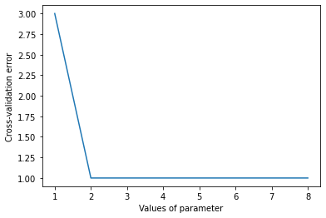Figure 1: C set to 0.1
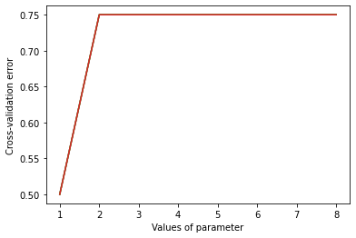Figure 2: Parameter C >= 0.5

Run No. | Value of C | Value of M | Training Error | Cross-Validation Error | Overfitting
1 | 0.6 | 1 | 0 % | 0.5 % | None
2 | 0.7 | 1 | 0 % | 0.5 % | None
3 | 0.8 | 1 | 0 % | 0.5 % | None
4 | 0.9 | 1 | 0 % | 0.5 % | None
5 | 0.6 | 5 | 0.5 % | 0.75 % | None

Part 1.3
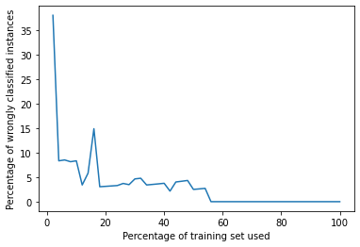
The percentage-split was altered from 2% to 100% with a step-size of 2 and the error rate was recorded. The graph displays the trend of error rate when the percentage split was altered between the defined range. The most interesting trends are reported in the table below. The error rate seems to be the highest when only 2% of the training set is used. After using 54% or more training examples, the error rate becomes a constant of 0%.

As the training examples are reduced the error rate increases, therefore the error rate is proportional to the number of training examples used.
One of the most interesting observations is when 14% of training examples are used and the error rate rises suddenly. It must be because certain examples from a particular class in the dependent variable may be ignored while slicing the 14% which contributes to the most error afterwards.
No. | Percentage of training set used | Cross-validation percentage
1 | 2 % | 38.01%
2 | 14 % | 14.881 %
3 | 30 % | 4.7794 %
4 | 48 % | 2.5 %
5 | 54 % | 0 %
6 | 75 % | 0 %
7 | 90 % | 0 %

Part 1.4
Although, with all the values of k, the difference between training error and cross-validation error remains in the range from 0.5 to 2 which signifies that overfitting is not present in any case. Thus, we will try to minimise this difference. As per our observations, the best value of k would be 4 as the difference between the training and cross-validation error is minimum with a value of 0.75 %. The highest difference can be observed in the case of k=8 where the difference is 2 % meaning highest possibility of overfitting.
Run No. | Value of k | Training Error | Cross-Validation Error | Overfitting
1 | 1 | 2.5 % | 4.25 % | None
2 | 2 | 2.25 % | 3.75 % | None
3 | 3 | 4.25 % | 5.25 % | None
4 | 4 | 4.25 % | 5 % | None
5 | 5 | 5 % | 6.25 % | None
6 | 6 | 5 % | 6 % | None
7 | 7 | 6 % | 7.5 % | None
8 | 8 | 5.5 % | 7.5 % | None
9 | 9 | 8 % | 9.25 % | None
10 | 10 | 7.75 % | 9.25 % | None

Part 1.5
I tried two classifiers named as LMT and Random Forest. Several iterations of the algorithms with different values of their parameters were performed to get the best models.
Random forest is the best model for our data as it has the least error and overfitting with max-depth =3 and number of iterations = 40. LMT also performed well but it contains some amount of overfitting and a higher error rate.

Run No. | Value of M | Batch-Size | Training Error | Cross-Validation Error
1 | 4 | 20 | 0 % | 2 %
2 | 7 | 50 | 0 % | 2 %
3 | 15 | 70 | 0 % | 2 %
4 | 21 | 100 | 0 % | 2 %
5 | 25 | 160 | 0 % | 2 %

Table for LMT

In random forest, after max-depth 5, training error was 0% with number of iterations >=10. The preferred number of iterations would be > 20.

Run No. | Max Depth | Number of Iterations | Training Error | Cross-Validation Error
1 | 3 | 40 | 0 % | 0 %
2 | 5 | 20 | 0 % | 0 %
3 | 6 | 20 | 0 % | 0 %
4 | 8 | 20 | 0 % | 0 %
5 | 9 | 10 | 0 % | 0.5 %

Table for Random Forest

Part 1.6
J48 has the highest predictive accuracy among OneR, ZeroR and J48. It does not show overfitting and has an error rate of only 0.5 %. OneR and ZeroR take into consideration only the most influential attribute whereas J48 is a decision tree algorithm which looks at the whole dataset and constructs a tree accordingly. Therefore, J48 is the best one.

Part 1.7
Good columns from al to ba.

Part 1.8

Question 2
Part 2.1
The least error was observed in ZeroR with no overfitting. M5P has a slightly better error but it seems to have more chance of overfitting than ZeroR as the difference between the training and cross-validation error is more in M5P than ZeroR. IBk performs the worst as it has the highest error and a lot of overfitting.
The best model is ZeroR as it has best accuracy with negligible overfitting.
Run No. | Classifier | Training Error | Cross-Validation Error | Overfitting
1 | ZeroR | 13.8138 | 13.835 | None
2 | M5P | 11.279 | 12.4825 | None
3 | IBk | 4.3683 | 17.0537 | Present

Part 2.2
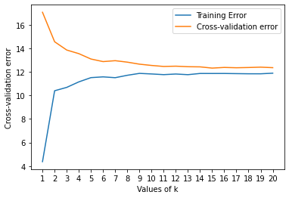
This graphs represents the trend of training and cross-validation error when the parameters of Ibk were altered. The best value of the parameter where the algorithm performs best in terms of both overfitting and predictive accuracy is when k=15 with a cross-validation error of only 12.3141. For k<9, the accuracy is low and there is a lot of overfitting which can be seen.
With some other parameters,the model showcased a similar performance.

IBk

Run No. | Value of k | Training Error | Cross-Validation Error | Overfitting
1 | 15 | 11.867 | 12.3141 | None
2 | 10 | 11.8619 | 12.5394 | None
3 | 17 | 11.8444 | 12.3436 | None
4 | 19 | 11.8309 | 12.3947 | None
5 | 20 | 11.8815 | 12.3508 | None

M5P
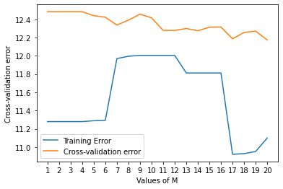
This graphs represents the trend of training and cross-validation error when the parameters of M5P were altered. The best value of the parameter where the algorithm performs best in terms of both overfitting and predictive accuracy is when m=20 with a cross-validation error of only 12.1728. For k<6, the accuracy is low and there is a lot of overfitting which can be seen. With some other parameters,the model showcased a similar performance.

Run No. | Value of M | Training Error | Cross-Validation Error | Overfitting
1 | 20 | 11.0989 | 12.1728 | None
2 | 17 | 10.9206 | 12.1858 | None
3 | 18 | 10.9282 | 12.2558 | None
4 | 19 | 10.9516 | 12.2699 | None
5 | 14 | 11.8114 | 12.2741 | None

Part 2.3
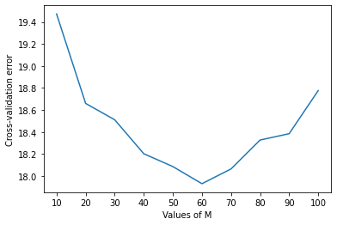
I tried using the classifier known as k-Star algorithm. This algorithm showed a lot of overfitting and with almost all parametric values, this cannot be overcome.

The cross-validation error is also quite high in this case and the graph shows the trend of the error values where the minimum error is reached when batch-size is put as 60. This algorithm is not good for use.

Run No. | Value of B | Training Error | Cross-Validation Error | Overfitting
1 | 60 | 4.0582 | 17.9307 | Present
2 | 70 | 4.3107 | 18.0648 | Present
3 | 50 | 2.8473 | 18.0865 | Present
4 | 40 | 2.5465 | 18.2031 | Present
5 | 80 | 5.7839 | 18.3275 | Present

Table for k start algorithm

Random forest

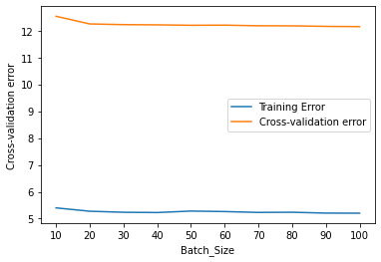
I also used the classifier known as random forest. This algorithm also showed a lot of overfitting and with almost all parametric values, this cannot be overcome.
The cross-validation error is also quite high but less than k star. in this case and the graph shows the trend of the error values which depict that overfitting cannot be overcome as training and cross-validation error lines in the graph do not seem to converge. This algorithm is also not good for use.

Run No. | Batch-Size | Training Error | Cross-Validation Error | Overfitting
1 | 100 | 5.2033 | 12.1528 | Present
2 | 90 | 5.2067 | 12.1623 | Present
3 | 80 | 5.2386 | 12.1818 | Present
4 | 70 | 5.2324 | 12.1842 | Present
5 | 50 | 5.2828 | 12.203 | Present

IBk used in Part 2.2 is the best algorithm to suit this task as it has negligible overfitting and the best predictive accuracy amongst others.
Part 2.4

Question 3

Part 3.1
At k =3 the best clusters were formed as they were easier to visualise than with other k values. The error rate also seems to decline suddenly and as per the elbow method, this value is the best. We could observe similar pattern with k=10 and k=20 but many clusters are formed with these values which makes the data more dense and hard to visualise.

Run No. | Value of k | Sum of squared errors (within clusters)
1 | 1 | 155.7566
2 | 2 | 143.4719
3 | 3 | 67.6526
4 | 4 | 63.2542
5 | 5 | 61.3460
6 | 10 | 38.6040
7 | 20 | 8.1104

Part 3.2
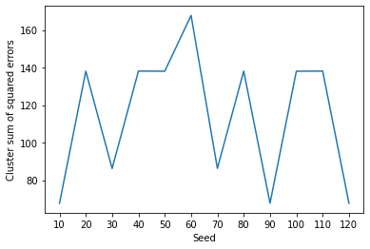
The graph shows the trend of changing the seed values from 10 to 120.A change in sum of squared errors within cluster is observed everytime the seed value is changed. Also, as I went with higher values of seed which had lower sum of squared errors like 120, the clusters were more precise and better to visualise.

Run No. | Value of Seed | Sum of squared errors (within clusters)
1 | 10 | 67.6526
2 | 20 | 138.0255
3 | 30 | 86.1961
4 | 40 | 138.091
5 | 50 | 138.0331
6 | 100 | 138.0255
7 | 120 | 67.6526
Part 3.3

There were 8 clusters created by cross-validation and the number of iterations was 41. The value of log likelihood was -9.68265. Almost all clusters were observed to be overlapping and were hard to visualise. With the age attribute clusters 1,2,6,5 were highly overlapping and rest could be told apart to some extent. For ‘bp’ and ‘pc’ all clusters were overlapping. ‘rbc’ had clusters 3,4,5,6 overlapping whereas cluster 0 had a good formation.
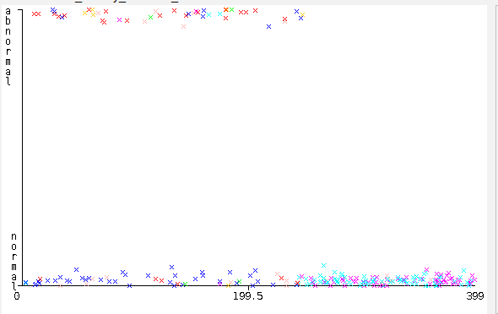Figure 3: Output for 'rbc'
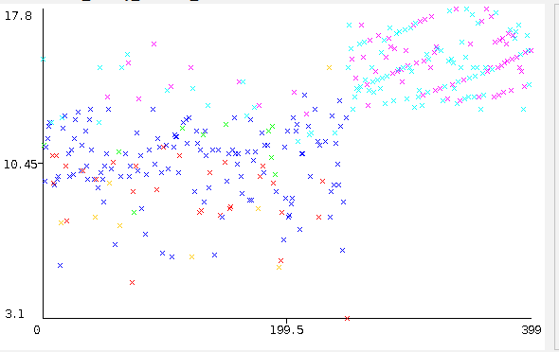Figure 4: Output for 'hemo'

The attribute ‘hemo’ had cluster 3,5 overlapping highly and cluster 0,1 with a less overlap.

Part 3.4
Number of clusters made = 3
log likelihood =

In age,bp,rbc, one cluster very good, two overlapping

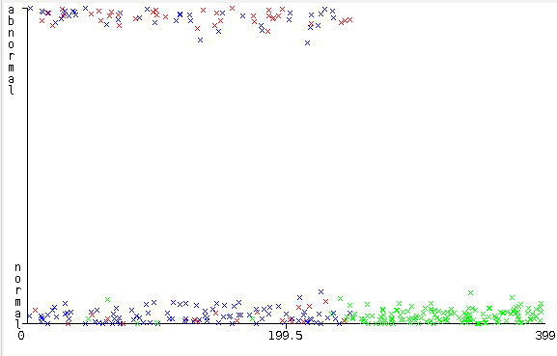
In pc,hemo, two clusters are good and one is overlapping

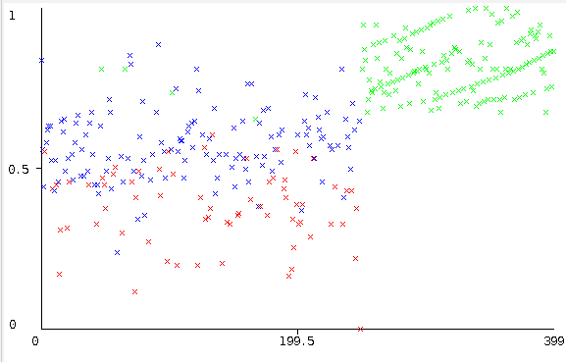

part 5

cv does not matter for values of both params below <.001 ,

if cv is >= iteration, does not affect, inversely proportional to the ratio between cv and iterating
negation from above increases likelihood an clusters.

Run No. | minLogLikelihoodImprovementCV | minLoglikelihoodImprovementIterating | minStdDev | LogLikelihood | No. of Clusters
1 | 0.000001 | 0.000001 | 0.000001 | 6.487 | 2
2 | 0.0001 | 0.000001 | 0.000001 | 6.487 | 2
3 | 0.01 | 0.000001 | 0.000001 | 6.487 | 2
4 | 0.5 | 0.1 | 0.1 | 2.07 | 2
5 | 0.25 | 0.1 | 0.1 | 2.76 | 3
6 | 0.1 | 0.25 | 0.1 | 3.01 | 5
7 | 0.25 | 0.25 | 0.1 | 2.705 | 3
8 | 0.000001 | 0.01 | 0.000001 | 8.136 | 5
9 | 0.000001 | 0.01 | 0.0001 | 7.848 | 6
10 | 0.00001 | 0.01 | 0.1 | 3.17 | 5

lower value of minstd , high clusters and likelihood

Part 6

3 cliusters

Part 7

Part 4: Association Finding

Question 1

Th file ‘bakery-data1.arff’ contains both yes and no values but in bakery-data2.arff only ‘yes’ is present and the remaining values are missing.

Question 2

The most significant associations have a confidence values of 0.98 and have ‘no’ values as the dominant category is ‘no’ and there are very less values for ‘yes’.
The highest confidence value that can be observed is 0.98 which makes around 228 rules. After testing with confidence values 0.9, 0.93, 0.95, it is seen that more than 900 rules can be formed which all have ‘no’ values.

After performing attribute selection through ‘CfsSubsetEval’, 13 attributes were selected and the same parameters were changed and tested. The highest confidence that could be seen now is 0.97 and the number of associations with the confidence 0.97 are decreased.

Question 3

No associations can be found with the default values of Apriori algorithm as there are very less values of ‘yes’ in the dataset and the others are missing.
By testing confidence more than 30 values between the range 0.1 to 0.99, no association could be found. After altering the lowerBouhndMinSupport between the range 0.01 and 0.1, there were some associations. When lowerBoundMinSupport was below 0.06, associations could be observed which is due to the fact that there are less values of ‘yes’.

Attribute selection cannot be performed as the dataset only contains a single class ‘yes’ and quoting the error from weka ‘Cannot handle unary class’.

Question 4

FPGrowth showed a similar performance like Apriori in which it was able to find associations in bakery1 and no rules in bakery2 but Filtered Associator is the best out of those as it gave rules in bakery2 ignoring the missing values. It is also more customizable as the hyper-parameter in filtered-associator named as ‘classIndex’ provided more control on which rules to look for. After choosing different indices in this parameter, the attribute in that index used to be present in the rule. Therefore, filtered associator is the best one.

Question 5

Question 6

The chronic disease data was pre-processed with ‘discretize’ to convert numeric values to nominal. Then attribute selection was performed using ‘CfsSubsetEval’ and filtered associator was used. There were atleast 10 rules in which some meaningful rules like ‘appet=good ==> rbc=normal’ could be found.

